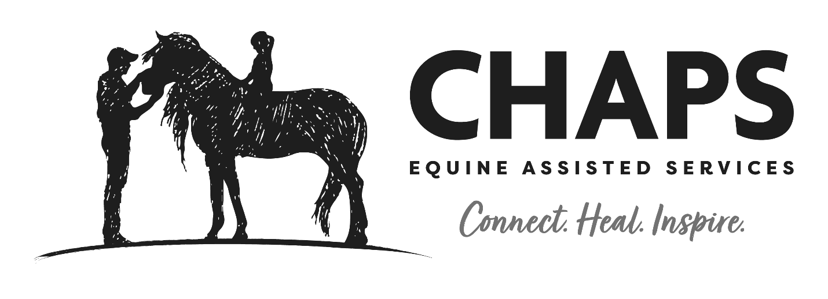
Children, Horses and Adults in PartnerShip for Equine Assisted Services
Driving Volunteer Handbook
17th Edition
February, 2022

Physical Address: 501 US Highway 14 East, Sheridan (no mail)

Mailing Address: PMB 201 1590 Sugarland Drive, Suite B
Sheridan, WY 82801
307.673.6161 info@chapswyo.org www.chapswyo.org
Table of contents
Welcome……………………………………………………………………………….…………...……………….………………………………….3
Contact Information……………………………………………………………………………….…………………………………...………….4
Organizational Structure………………………………………………………….………………………………………………………………5
About CHAPS Equine Assisted Services…………………………………….………….……….……………………………….…………6
Property Map….………………………………………………………………………………………….……………………………………………7
Where is it? Quick Reference……………………………………………………………………………………………………….………….8
Universal Volunteer Standards and Guidelines
The Basics………………………………………….………………………………………………..…………………………………9-10
Continuing Education…………………………………………………………………………..……………………………………10
Dress Code……………………………………………………………………………………….……………………………………….10
Parking………………………………………………………………………………….………………………………………………….11
Signing in………………………………………………………………………………….………….……………………………………11
Barn Etiquette………………………………………………………………………………………….……………………………….11
Emergency Procedures……………………………………………………………………………………………………………….………...12
Natural Disaster Emergencies ……………………………………………………………………………………………………………….13
COVID Procedures…………………………………………………………………………………………………………………………….14-18
Driving Volunteers
Driving Policy ……………………………………………………………………………………….………………………………19-22
Common Rules and Guidelines…………………………………………………………………..……………………….…….23
Horse Header……………………………………………….………………………………………………………..…………………24
Able Bodied Whip……………………………………………………...………………………………..……………………………25
Reasons for Volunteer Dismissal……………………………………………………………….……………………………………………26
Parts of the Harness……………………………………………………………………………………………………………………………….27
Glossary…………………………………………………………………………………………………………………………………………………28
Functions of the Harness………………………………………………………………………………………………………………………..29
Wraps……………………………………………………………………………………………………………………………………………………30

Dear Volunteers,
What makes a good volunteer?
Are they good because they have the technical skills to do the job correctly? Is it because they are enthusiastic and eager to help? After years of practice as a volunteer, I believe it is dedication and passion; believing in what you do and being committed to the mission.
It also includes a promise by the program to provide you with all the tools and skills you need to do your job successfully and have a safe and happy workplace. To be responsible and reliable to you, the volunteer, by making sure that your time is not wasted or squandered.
Our obligation to you includes offering you the training and support you need. Working with horses and people with special needs requires the guarantee of proper training so you can be safe and comfortable in your time spent at CHAPS. There are several standards and guidelines to uphold in order for our services to be meaningful to our clients.
CHAPS Equine Assisted Services is a professional organization providing high quality equine assisted activities and therapeutic riding. We want you to be proud to be part of our team, and ask that you make the commitment to excellence by taking our volunteer training classes seriously, while still having fun and enjoying what you are doing.
Most importantly, know you are a part of something much bigger than one person or job. You are helping others and making a difference in their lives. Thank you.
Sincerely,
Kristen Marcus
Kristen Marcus
Executive Director

CHAPS Staff and Board of Directors Contact information
Board of Directors:
President:
MIkole Soto, 307-429-9932
Vice President:
Kristen Masters, 307-751-9459
Secretary:
Shana Neustel, 307-217-0509
Treasurer:
Devin Worman, 307-760-0106

Executive Director:
Kristen Marcus
Work phone: 307-673-6161, info@chapswyo.org
Administrative Assistant:
Teresa Garrett
Cell phone: 307-763-1210, volunteercoordinator@chapswyo.org, Work phone: 307-673-6161
Instructors:
Tracy Shaw, PATH International Riding & Driving Instructor
Cell Phone: 307-680-2331, tracy@chapswyo.org, CHAPS 307-673-6161
Fleur Ahern, PATH International CTRInstructor
Cell phone: 307- 737-2252, fleur@chapswyo.org, CHAPS 307-673-6161
Barn Manager:
Gina Marchese
Cell phone: 719-659-5790, gina@chapswyo.org, CHAPS 307-673-6161

Organizational Chart

Stakeholders in our Community

CHAPS Board of Directors
CHAPS Executive Director
Administrative or Fundraising Volunteers
Volunteer Coordinator
CHAPS Instructors
CHAPS Barn Manager

Stable Volunteers Feeders and Stall Cleaners
Session Volunteers
Horse Leaders and Side Walkers

About CHAPS Equine Assisted Services

CHAPS is a Premier Member Center of the Professional Association of Therapeutic Horsemanship International (PATH, formerly NARHA) and we adhere to their rules and guidelines, as well as using their forms and procedures in all aspects of our activities. PATH was founded in 1969, and they are widely recognized as the industry leader for Equine Assisted Activities and Therapeutic Riding. Their emphasis – and ours – is on safety, appropriate conduct, and outstanding service to equestrians with special needs.
We believe that PATH has developed an outstanding system of keeping equine assisted activities and therapeutic riding sessions safe, challenging and satisfying for everyone involved. If you have a question about any of our rules and guidelines, please do not hesitate to ask a staff member for an explanation. We also have a library of books and videos available, including the PATH Standards and Guidelines, for you to check out to read.
There are many benefits to being a member of PATH – if you are interested in learning more about their organizational structure, please visit the PATH website, www.pathintl.org.

The people we serve:
Our clients present to us with a variety of diagnoses, including but not limited to Autism, Down Syndrome, Developmental Delay, Traumatic Brain Injury, Paralysis, Visual Defects, Cerebral Palsy, Multiple Sclerosis, PTSD, Behavioral or Emotional Issues. We are committed to providing them with respect and high-quality services that maximize their abilities and potential.
We serve people ages four and up with a variety of activities for clients:
- Therapeutic Riding: a traditional riding lesson in English or Western style riding and horsemanship that also addresses each individual client’s special needs. Lesson plans are developed with input from the client’s support team, which can include family members, educators, medical or therapy professionals, and volunteers.
- Therapeutic Driving: a traditional driving lesson with therapeutic goals. Lesson plans are developed with input from the client’s support team and the client.
- Equine Assisted Activities: activities that include ground work, grooming, leading and stable management for clients who are unable to ride.
- Equine Assisted Learning: Clients work in teams or individually on horsemanship skills in the presence of a counselor or educator to develop team work and social skills, confidence, self-esteem and address behavioral, emotional or mental health issues.
- Equine Facilitated Psychotherapy: In cooperation with the Sheridan VA Medical Center Psychiatric staff, this is an experiential form of therapy using horses as metaphors to promote learning and healing.

Property Map
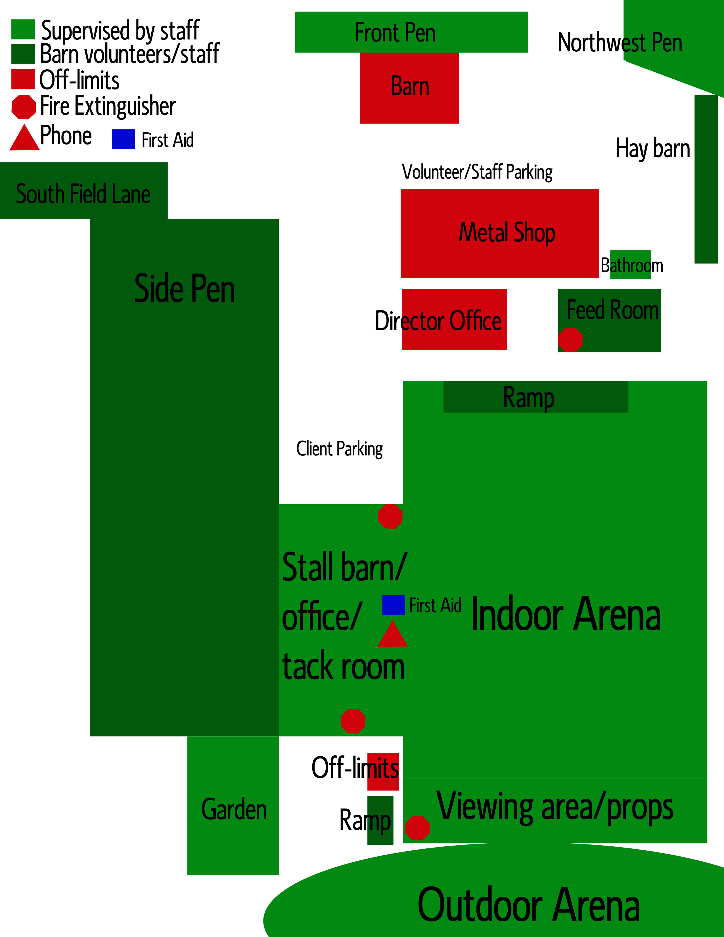

Where is it? A quick reference for important CHAPS stuff…
Telephones / Emergency call protocol: located in the Instructor’s office and outside of the Instructor’s office on the FYI board.
First Aid Kit in the Instructor’s office in a black tool kit on top of the refrigerator
Equine First Aid: in the white trunk outside of the Instructor’s office and temperature sensitive items in the yellow tool kit in the Instructor’s office on top of the refrigerator
Director’s office is in the tan/green building between the arena and metal shop
Bathroom is a handicap accessible Port-a-John located on the North side of the silver metal building
Feed room is the tan building between the arena and metal shop
Water source: Multiple frost hydrants located around the property. One is located in the South East end of the Indoor Arena; a second is located behind the feed shed. A third is located on the main driveway near the Front Pen. There is one located in the North West Pen as well. This water is not potable. It is OK for the animals to drink, but not people.

Universal Volunteer Standards and Guidelines
Your handbook will break down each separate volunteer opportunity in detail, but there are many guidelines and rules that apply to all volunteers at CHAPS.
The Basics…
- It is your responsibility to read your handbook and refer back to rules and guidelines and standard operating procedures. An electronic copy is available upon request.
- CHAPS volunteers must be at least 16 years of age and complete the volunteer class before handling horses or participating in any client or horse-based volunteer activities.
  - Volunteers aged 16 – 18 must have parental permission. Some exceptions may be made for younger volunteers on a case-by-case basis and with approval from the Executive Director, Instructor and Barn Manager.
- Observe confidentiality – what you are told regarding a client to help you while working with them is private and not for discussion outside of CHAPS. If you meet a client in public, please allow them to contact you first.
- If you are unable to be at your assigned time to volunteer, please call the CHAPS number at 307.673.6161 immediately. Not showing up without notice can keep clients from riding. We understand that life happens – please give us time to find a fill in for you!
- CHAPS is not responsible for items brought into the barn and left unattended while you are volunteering. Please leave purses, backpacks, etc. locked in your vehicle.
- Please leave pets at home. Pets are not allowed on the premises and should not be left in vehicles where the temperatures can reach over 100 degrees F or drop below freezing. The only exception is a service animal.
- Service animals must be in a vest, have leash attached, be put on a STAY command while in the barn and be put on a STAY command in the viewing section of the arena. No barking, biting or chasing cats or horses is allowed. If the service animal cannot meet these criteria, they are not allowed on the premises. They cannot be left in a vehicle as it gets hot which may result in overheating and possibly death.
- Please leave electronic equipment – cell phones, iPods, etc. – in your vehicle.
- If your job requires you to carry a weapon, leave it locked in your vehicle. Otherwise, leave weapons at home. Pocket knives are allowed if you are a feeder volunteer.
- Make sure that you have filled out the medical authorization form on the general liability release so our staff can seek attention for you if you have a medical emergency. Knowing what medication/s you are taking is helpful to medical personnel, and is confidential.
- Volunteers are models of behavior for our clients. Please observe all barn etiquette roles and safety procedures to set a good example for our clients!
- Refrain from foul language or using derogatory terms
- CHAPS is a secular organization and is open to people of all religion, race, creed or color.
- When volunteering alone, you must call or text the Director, Instructor or Barn Manager on their cell phone at the end of your shift to let them know you are done and that all is well.
- The computer is for CHAPS staff only unless you are providing office support. A tablet is provided for logging volunteer hours at the end of your shift.
- Do not represent yourself as an agent of CHAPS to request money, donations or funding without first speaking to the Director. Please join the fundraising committee if you are interested in helping CHAPS raise money for the program.
- CHAPS is a tobacco and alcohol-free facility; smoking, chew and vapers will not be tolerated on property.

Continuing Education
All session volunteers must re-certify annually in order to continue to volunteer at CHAPS. This fulfills requirements from our insurance company and PATH International.

Dress Code
- Wear comfortable shoes that protect your feet and ankles. Waterproof foot wear is preferred for walking outside, especially in the spring and winter. No sandals, open toed shoes or open backed clogs or slides. Sneakers are allowed but not recommended for handling and working around horses.
- Long pants to protect your legs. We have rattlesnakes and biting insects in the summer! Shorts will not provide you with protection from the elements but are allowed in extreme heat.
- Button up shirts with collars, long or short sleeve t-shirts are recommended. No midriff or spaghetti strap shirts are allowed. Sleeveless shirts should be appropriate when representing CHAPS.
- Gloves are recommended when doing stable work or handling and leading horses. Mittens are not recommended during the winter as you will need the use of your fingers to manipulate gate latches, blanket buckles, halters and such.
- Hats, sunglasses and sunscreen are advised during the summer. However, some of our clients may remove your hat without warning – be prepared. Bring plenty of water during the hot months since CHAPS does not have a water source suitable for human consumption.
- Dangling or excessive jewelry can get caught in manes, tails, or be snatched by a client or distract them during a session. It is better to not wear these items during sessions.
- No clothing with offensive or suggestive messages or slogans that promote alcohol or drug use. Some of our clients are here to learn to cope with addictions.
- Everyone on a horse MUST wear a helmet. NO EXCEPTIONS! When mounted, please wear long pants – jeans or riding breeches and boots with hard sole and low heel. Please, no tennis shoes.
Parking
- Please park in front of the metal shop or on the North side of the arena unless otherwise instructed.
- The front door parking area is for clients and client drop off only.
- Please do not park around the green rental house, that area is reserved for the people living there.
- Do not park in front of the work truck and horse trailer. We need access at all times in case of an equine emergency.
Signing in
- Please make sure that upon arrival or before leaving CHAPS, you log your volunteer hours on the chart provided. Our Director uses your volunteer hours to show community support in the form of “in-kind donation” of services when writing grants and requesting financial support for the program.
Barn Etiquette
- No running, screaming or boisterous behavior.
- Please do not reach into horse’s stalls through the bars. Horses at CHAPS appreciate privacy in their stalls and may injure hands, arms or fingers that are inserted into their stalls.
- Clients are not allowed in the barn area without an Instructor present. If they show up early, and a session is in progress with the Instructor in the arena, please ask them to wait in their cars or the garden until the Instructor calls them in.
- Do not bring family and friends to help or watch while you volunteer, as they are not covered under our liability insurance or confidentiality clauses. Please encourage them to attend a volunteer class and join in as a certified volunteer instead!
- No cell phones, personal stereos or music while volunteering. Please leave these items, as well as pocketbooks and/or personal items in your vehicle while working with horses or clients.
- All gates will be propped on the wooden blocks and securely fastened at all times. Don’t plan to go back and shut them later – shut them right away!!!
Emergency Procedures

In all emergencies, notify the Director and/or Instructor on duty immediately.
Stable Emergencies – General information
- Never leave a client alone in the barn during an emergency. Wait with them in the office or in the parking area, depending upon where the emergency occurs (move the clients to the farthest possible point from the situation for their safety).
- Protocol for encountering a rattlesnake is posted on FYI board outside the Instructor’s office.
- You may be asked to call for emergency assistance. The directions to CHAPS from Sheridan and Buffalo are posted by the phone and other locations for you to give to 911 operators. Follow any directions given to you by the Instructor, Director and 911 dispatchers.
- Building emergencies – broken equipment, such as gates or doors breaking, fences down, etc. Alert a staff member to the problem, make sure you and the client are safe, and then assist the staff member if asked.
- Emergency Operation Procedures are located on the FYI Board in the event of an emergency. Knowing and understanding emergency protocol will make your job easier and safer.
- If a horse gets loose, alert other staff, take a halter and lead rope and bucket of grain and attempt to head the horse back towards the barn and away from the highway. If the horse enters the highway, attempt to coax him back with a bucket of grain. If there are enough people (NOT CLIENTS) to flag down traffic FROM A SAFE DISTANCE without entering the highway, do so. Do not risk your life to get the horse back. Never allow clients or their caregivers to help catch a loose horse (unless the caregiver has completed the volunteer training and has signed a liability release). Have clients wait with another volunteer or their caregiver(s) in the barn by or in the office or a safe location (vehicle, empty stall, etc.) where they will not be run down by a running horse.
- Keep in mind that horses are herd animals and would prefer not to leave their companions. Try to allow the horse to circle back to the barn by going out and around them, blocking their exit to the driveway and beyond.
- If a horse falls in the aisle or is cast in a stall do not attempt to get them up alone. Alert staff. Try to let the horse get up alone in the aisle, move any obstacles out of the way. If they are cast in the stall do not try to grab their legs. Let the Barn Manager or Director direct the rescue efforts, do not go in the stall alone. If you are alone when this happens, call the Director or other emergency contacts on the telephone list.
- If a horse becomes agitated and bites or kicks a client, staff member or volunteer, help that person to a chair or safe location away from the horse and alert the Instructor and or Director. Allow them to perform any first aid necessary.

Natural Disaster Emergencies

- Thunder/Lightning: If a severe storm disrupts a lesson, follow the directions of the Instructor to dismount or calm the clients and horses. If the storm occurs when horses are in the barn, shut windows and doors and wait out the storm. Do not contact standing water until the storm has passed. If horses are turned out allow them to seek shelter in their pastures.
- Tornadoes: Seek shelter in the office inside the stable, under a table or desk. Do not attempt to catch horses if they are out. Leave the barn doors open.
- Blizzard: Horses may be moved to pastures with run in sheds, in extreme weather they may be brought into the stalls and indoor arena. If a blizzard occurs and you are trapped at CHAPS, you may stay in the heated feed shed and alert the Director or your family. When the blizzard has passed the CHAPS staff will make every attempt to clear the parking areas and driveway for vehicles to pass.
- Flood: CHAPS is not in a flood plain, however, the barn is occasionally lightly flooded during heavy rains or during irrigation. First check to make sure no electrical appliances are in standing water. If possible, push water out the front of the barn with push brooms.
- Earthquake: Leave the indoor areas and go to the outdoor arena or field until the earthquake has passed.
- Fire: Get out of the building, take your client with you, and use any available cell phone or go to one of the houses on the property to have them call 911. Do not attempt to save belongings or items. Do not attempt to save horses. Your life and the client’s life is the priority.

COVID – 19 Protocol Operating Procedure
General: During sessions, minimal physical contact and strict disinfection protocols will be adhered to. All efforts will be made to minimize the number of individuals on property at any given time. Clients and volunteers will be scheduled so as to avoid overlap and prevent extended periods on property. As per the client and volunteer surveys; any individual who has tested positive for COVID – 19, has been in direct contact with an individual who has tested positive for COVID – 19, has travelled outside the State of WY in the last 14 days or has exhibited symptoms of COVID – 19 including but not limited to cough, shortness of breath, fever and chills in the last 14 days will not be allowed on property. All staff will practice social distancing and adhere to CDC guidelines for preventing the spread of the virus to the best of their abilities and as the facility allows (https://www.cdc.gov/coronavirus/2019-ncov/prevent-getting-sick/prevention.html).
Client screening: A risk assessment worksheet will be completed for all currently enrolled clients. The worksheet will be completed by the Instructor and client (or legal guardian). Upon completion of the risk assessment worksheet, the Executive Director will review the worksheet and approve or deny the client’s participation at CHAPS and the client (or legal guardian) will agree to the potential risks. The approved client will then be provided with a new contract stating the modified trimester dates, an adjusted payment plan, a medical history release stating that they are, to the best of their knowledge, negative for COVID – 19, and a copy of the COVID – 19 Operating Procedures document. A denied client will be required to wait until CHAPS is no longer operating under the COVID – 19 Protocol to resume participation. Should a client be denied full participation at CHAPS they may request a modified lesson plan to minimize or eliminate the potential risk of contracting COVID - 19 posed to CHAPS staff and volunteers.
Client Restrictions: Clients will arrive no earlier than ten minutes before their scheduled lesson. They must remain in their vehicle until their Instructor comes to get them. The client will be escorted to and from the arena by the Instructor. The client will be restricted to riding/driving activities only. They will not be allowed to participate in the catching, haltering, grooming, tacking/harnessing, or untacking/unharnessing of their horse. This is to limit the exposure of the horse and equipment to staff only. Only one additional individual will be allowed in the viewing area to support the client. Any other family members, support staff or other will be required to stay in their vehicle at all times. Vehicles will not be kept running as the fumes and loud music/radio are a distraction and danger to the horses and clients. The viewing individual will be escorted to the viewing area by staff and will be asked to disinfect their hands after leaving their vehicle and before exiting the viewing area.
Volunteer Duties: All volunteers will be required to fill out a risk assessment before being allowed to participate in any activity. Volunteers will be restricted to only the duties performed in the arena (leading and side walking). While under the COVID -19 Protocol; volunteers will not be allowed to catch, halter, groom, tack/harness or untack/unharness. This is to limit the exposure of the horse and equipment to staff only.
- Volunteers will be asked to wait in their vehicle until ten minutes before the lesson.
- Volunteers will be asked to disinfect their hands upon exiting their vehicle, before coming into contact with the client or horse and equipment (leader/header - lead rope, side walker/ABW - tack/harness).
- Volunteers will enter the Arena from the parking lot thru the gate located at the west end of the Indoor Arena.
- Volunteers will provide aid to the client from the back or side as much as possible. The goal is to avoid standing directly in front of the client as much as possible.
- Volunteers will leave through the gate at the west end of the arena immediately after the Instructor takes control of the lesson horse.
Volunteer hours will be tracked electronically and from a remote site, the clip board will not be used. It will be the responsibility of the volunteer coordinators to track when a volunteer comes onto and leaves the property at any given time. Volunteers will be required to wear a mask anytime they are in the arena. All volunteers must watch the video on how to properly wear a mask and it will be noted in their file they have watched it.
Instructors:
- Instructors will be responsible for catching, grooming and tacking/harnessing the horse before the lesson.
- Once done, the Instructor will lead the horse into the arena where the volunteer will be waiting.
- The Instructor will escort the client into the arena from the parking lot through the gate located at the west end of the arena after disinfecting the client’s hands (if applicable based on the client).
- Instructors will teach and provide aid to the client from the back or side as much as possible. The goal is to avoid standing directly in front of the client as much as possible.
- After the completion of the lesson the Instructor will escort the client back to their vehicle through the gate at the west end of the arena.
- The Instructor will return to the arena to take control of the lesson horse from the volunteer and return to the barn for untacking/unharnessing, brush down and turn out.
All tack and grooming supplies will be moved to the back of the barn by the garden (during good weather) or into Stall #3 (during poor weather) where it will be disinfected and returned to the tack room at the end of the day. No grooming tools or tack will be used consecutively without first being disinfected (reins, helmets, driving gloves, etc.). No lesson horse will be used in two lessons back to back, they must be allowed time for turnout (UV disinfection). Masks must be worn by all volunteers and clients. Staff will wear them except when teaching in excess of 6 feet away.

Instructors will need to disinfect with hand sanitizer between each lesson. Instructors should use hand sanitizer:
- Before pulling out tack and grooming supplies
- Before catching the lesson horse
- After handing off the lesson horse to the volunteer and before coming into contact with the client
- After escorting the client to their vehicle and before taking back control of the lesson horse from the volunteer
- After turning the horse out
- After moving tack to the designated disinfection area
Tack: All grooming tools, tack, helmets, driving gloves and halters/lead ropes will be disinfected at the end of each lesson day.
- A disinfectant spray can be used on saddle pads, driving gloves, helmets, headstalls, halters/lead ropes and cross ties.
- Disinfectant wipes can be used on reins, cinches/girths, saddles, bareback pads.
- A bleach bath can be used for the grooming tools.
- Any props or toys used during the lesson will need to be taken to the disinfection area and cleaned before being used in another lesson. Ground poles, cavalettis, ring stands, the bridge, etc. will need to be sprayed down with disinfectant before being put away.
Facility: All staff will participate in end of day disinfection of the main barn area
- Gates: into barn (west end), into arena (west end), into viewing area
- Sliding doors: into arena, west and east end of Indoor arena, west and east ends of main barn
- Door into Instructor’s Office, chain pull on both sides of Arena double doors
- Groom stall/saddle stall doors, Stall #3 door when being used as disinfection area for tack
- Light switches/pulls: Indoor arena, Instructor’s Office, Main barn
- Common areas:
  - Cross ties
  - Saddle racks
  - White table
  - Writing utensils
  - Office chairs and counter, refrigerator and microwave handles
  - Broom closet clip
  - Handles on muck forks, muck shovel, brooms
  - Handles on muck carts
  - Sure Hands Lift Sling, winch control, stool, cone
These COVID-19 Operating Procedures are subject to change as the situation progresses, and regulations and state orders change. As the Operating Procedures change, CHAPS will provide an updated version of this document to all pertinent individuals.
The Port-a-potty is available for everyone. It should be used sparingly and when used, the handles and seat must be wiped down with sanitizer. It will also be cleaned at the end of each day.
Annex A to CHAPS COVID 19 Procedures
Annex A to CHAPS COVID 19 Procedures
June 1st, 2020
As per the Sheridan Public Health Official Debra Haar:
Volunteers and clients will be allowed to catch and groom horses, effective June 8th, 2020. Volunteers and clients may enter through the main barn door. In order to continue practicing safety in regards to public and client health, volunteers will be required to disinfect (hand wash or hand sanitizer); before catching, after grooming and tacking but before entering the arena for the lesson and upon return to the barn after turnout. Clients will be required to disinfect (hand wash or hand sanitizer); after grooming but before entering the arena to mount, and upon completion of grooming after the lesson. During grooming, tacking and mounting, it is strongly recommended that all persons involved (clients, volunteers, instructors, etc.) wear a face mask to stay in compliance with the social distancing guidelines released by the CDC. Face masks will be supplied by CHAPS and are available upon request. In addition, all tack and grooming supplies will be set aside for disinfection at the end of the day as per the COVID – 19 protocol. In addition, volunteers will track their own hours on the chart located on the broom closet door next to the Instructor’s office. Volunteers will need to disinfect with hand sanitizer before and after using the community marker. The hours will be documented by the volunteer coordinator and the chart and marker will be sanitized at the end of every day.
Annex B to CHAPS COVID-19 Procedures
September 21, 2020
As per the Sheridan Public Health Official Debra Haar:
Effective September 29th, 2020 any volunteer, client or staff member that tests positive for COVID-19 must quarantine for a minimum of 10 days, and then must be symptom free for a following 48 hours before being allowed to return to the CHAPS facility in any capacity. Anyone who tests positive will be required to have a letter of release from Public Health after completing the quarantine and symptom free periods.
Any volunteer, client or staff member who happens to be in close contact of a positive case, but does not show symptoms or receives a negative COVID-19 test result, will be required to quarantine for a minimum of 14 days with the following 48-hour symptom free period. If during the 14-day period you remain asymptomatic, you may return to the CHAPS facility. If you develop symptoms at any time during the quarantine period or receive a positive COVID-19 test result, you must extend quarantine for an additional 10 days from onset and then remain symptom free for an additional 48 hours before being allowed to return to the CHAPS facility. Should you receive a positive COVID-19 test result during close contact quarantine you will be required to have a letter of release from Public Health after completing the quarantine and symptom free periods.
MASK POLICY
The CHAPS Board of Directors has declared the use of masks to be up to each individual and his/her comfort level. Due to the nature of lessons, exertion is common and breathing through a mask while exerted is difficult. The State of Wyoming does not require any organization to require masks at this time. Therefore, the use of masks at CHAPS is up to each individual.
A COVID-19 liability release MUST be signed by every client/guardian/caregiver, volunteer and staff member before they participate in activities at CHAPS, effective June 2, 2020. Every client and volunteer will complete a COVID-19 Risk Assessment to help them determine their comfort level.

CHAPS Driving Policy
CHAPS driving program utilizes horses in ground and vehicle exercises to provide various forms of services for our clients. These exercises may include hitching horses to vehicles, ground driving horses, or various ground exercises to provide physical, and emotional therapeutic services for our clients. While horse driving provides exceptional experiences for those in need through rhythmic motion and emotional connection with horses for clients who are unable (or want something different) to engage in riding, horse driving is still an inherently dangerous activity. These policies attempt to limit the dangerous nature of horse driving to ensure that our horses and humans are safe. For this reason, these policies will guide all interaction in the driving program.
POINTS TO REMEMBER:
- The PATH International Premier Driving Standards and CHAPS policies will also be utilized as part of the CHAPS driving program.
- CHAPS approved helmets and driving gloves will be used by all people in the vehicle or driving.
- ANY PERSON MAY STOP A DRIVING SESSION FOR ANY PERCIEVED SAFETY RISK TO HORSES OR HUMANS AT ANY TIME.
PANDEMIC/ SANITATION POLICY
CHAPS cares about their clients, volunteers, and staff, so CHAPS driving will utilize CDC guidelines for sanitation. These guidelines may include sanitizing equipment, utilizing masks or other procedures that protect our horses and humans at all times. CHAPS Driving will always utilize hand sanitation techniques before and after sessions for all humans that interact in our program.
GROUND PROCEDURES (INCLUDING HARNESSING/ UNHARNESSING)
CHAPS works to ensure that both our horses and humans are safe at all times. This means that any ground procedure will be conducted in accordance with other CHAPS procedures. Horse driving includes harnesses to connect the horses to a vehicle. Harness has many different parts and can be extensive in parts. The parts all have a function in the driving process, and must be utilized appropriately to ensure a safe encounter for all involved. To ensure common communication between everyone involved in the program, all people working in the driving program will be provided a harness parts list, then will be expected to learn the basic parts and their use.
During the grooming process the driving program will utilize the CHAPS grooming procedures.
At the harnesses point, the driving program will harness each horse in the harness provided for each horse. The harness will be put onto the horse working from the front to the back.
- Driving collar/ breast strap will be put onto the horse first.
- Hames/ breast strap with tugs will be put on next (if utilizing a collar, the instructor will place the collar over the head).
- Main body of the harness (including saddle with double girth and spider) will be put on next. The britching of the harness will be left up on the hips of the horse (on top of the spider) until the double girth has been secured. The girth should not be tight, but instead loose to allow for the shafts to move freely during driving.
- Next the britching can be placed around the horse’s hind quarters and the cropper buckled in place.
- The instructor will then place the bridle on the horse. The lines will wait for placement until the horse is in the arena.
Unharnessing will reverse the process.
The instructor will then check all the harness to ensure that each piece is placed correctly and is buckled appropriately. The instructor will also check to make sure that no parts will fall and trip the horse while walking into the arena. Only then may the horse be taken into the arena according to CHAPS entering and exiting arena policies.
The use of double lines allows for both client and able-bodied whip/ instructor to maintain control of the horse at the same time. The primary lines that the able-bodied whip/ instructor hold will be the primary lines and be the main control lines for the session. The secondary lines may be connected to the saddle turrets, halter or bit depending on the experience level of the client. ONLY experienced and independent clients may drive without the use of secondary lines.
If at this point the horse will be ground drove, the header will take the horse into the center of the arena for the lines (both primary and secondary) to be put onto the horse. If the horse will be hooked to a vehicle, please see hitching procedures.
During ground driving procedures, the header will stay at the head until the driver states “my horse”, then the header may take the lead rope off the horse and move out of the way allowing for the able-bodied whip and client to take control of the horse. At the end of the session, the header will come into the center of the arena and take control of the horse after the client has stated “your horse”.

HITCHING/ UNHITCHING PROCEEDURES
Hitching horses to a vehicle will at all times require a header to ensure that the horse is under control at all times when clients and staff/ volunteers are on the ground. Additionally, an able body whip or the instructor will always have the lines to the horse controlled in their hands during the hitching process. This will provide two points of control to the horse during hitching.
The instructor will determine if the client will be allowed to help hitch the horse. Client involvement will be determined based on independence of the driving client and knowledge. Prior to clients being allowed to hitch they will have knowledge of harness parts, ground driving and the mental/ emotional stability to engage in the process.
Hitching may be done in the middle or nosed into a straight edge of the wall of the arena depending on the client and their needs. The instructor will determine the placement of hitching process before the start of the lesson.
To hitch/ unhitch the horse:
- Header will place the horse in the placement as requested by the instructor. The header must be aware and engaged with the horse at all times. The header will also help keep the horse calm during the hitching process. The header will always have the right to stop hitching process at any time, if they do not feel the horse or themselves are in a safe position.
- The lines of the horse will be attached at this point by the instructor. If double lines are being utilized the controlling lines will take precedence in contact with the horse’s mouth. The instructor or able body whip will maintain contact with the primary lines at all times until they are removed. The secondary lines may be set in the vehicle during the hitching process.
- The instructor and an additional person will stand on each side of the vehicle shafts and will pull the vehicle to the horse from behind, providing the horse time to become aware of the moving vehicle coming at them from behind. If the able-bodied whip is not on the lines during moving the vehicle to the horse, the instructor will grab the lines as soon as possible to provide a second point of control during the hitching process.
  - If the vehicle is too heavy to pull or a team is being hitched the process will be adapted.
    - If the vehicle is too heavy to pull up to the horse, the header will move the horse into position by walking the horse in front of the vehicle, then backing the horse into the shafts. In this situation, the shafts will be held into the air by the people hitching while the horse is backed into the vehicle by the header
    - If a team is being hitched the headers will walk the horse individually into each side of the tongue, then the instructor will cross the lines of the horses and take the lines to maintain a second point of control during the hitching process.
- The shafts of the vehicle will then be guided through the shaft carriers on both sides by each person on their own side. The point of the shafts should hit approximately the midline of the shoulder of the horse.
- The first thing to be connected in the hitching process is the tugs. The tugs provide the pulling power between the horse and the vehicle through the collar/ breast strap. The two people hitching may then hook the tugs to the vehicle ensuring that all the leather is straight and unrestricted. The tugs should be run under the shaft carrier but above the saddle girth. The tugs will then be connected to the cart in a manner that ensures the tugs are not loose when the horse moves out with the vehicle and both sides are in the same hole at the single tree (connection place on the vehicle).
- The next thing to be connected in the hitching process is the hold back straps. The hold back straps (attached to the britching around the horse’s hind quarters) provide the stopping power between the horse and vehicle. The hold back straps should be attached to the shafts by wrapping the strap through the shaft loops (metal loop on the shafts) and moving forward in a wrapping motion. The strap should be started from the inside of the shaft and moving around the shaft in a forward motion in one or two wraps. Then the strap will be run back to the buckle at the harness by running the strap under one of the loops on the shaft and buckling it at the britching. Both sides of the hold back straps should be done the same. Then the tightness should be checked by placing three fingers between the britching and the horse’s hindquarters to ensure correct holdback strap placement.
- The horse should be hitched at this point and the instructor will then check all of the harness and hitching to ensure correct connection to the vehicle.
- The able body whip/ independent driver or instructor may enter the cart at this point. Then the client will be allowed to enter the vehicle.
  - When Clients are entering the vehicle, they are in the most compromising position in the driving process, so the process should only be started after the instructor ensures that everything is correct and the horse is ready to be completely still during loading and unloading. ANY PERSON IN THE ARENA MAY CALL A STOP TO THE LOADING AND UNLOADING PROCESS. Stops may be called for any reason. The header may determine that horse that is not ready to stand during the whole process. Everyone should be aware of the harness and call a stop if harness/ hitching is not correct. Client may call stop if they are not ready to enter. Any reason should be taken seriously in calling a stop to the loading and unloading of clients.
- The header will stay at the head until the driver states “my horse”, then the header may take the lead rope off the horse and move out of the way.
- During the unhitching process the header will come into the arena and take control of the horse when the client states “your horse”. The order to unhitch the horse will be reverse from hitching.
- After the horse has been unhitched, the lines will be removed and the horse may be taken from the arena for unharnessing.
IMPORTANT POINTS TO REMEMBER:
- The PATH International Premier Driving Standards and CHAPS policies will also be utilized as part of the CHAPS driving program policies.
- CHAPS approved helmets and driving gloves will be used by all people in the vehicle or driving.
- ANY PERSON MAY STOP A DRIVING SESSION FOR ANY PERCIEVED SAFETY RISK TO HORSES OR HUMANS AT ANY TIME.
CHAPS driving program works to ensure that all sessions are safe and fun for every person and horse involved in the program.

Driving Volunteers
Common Rules and Guidelines for Driving Volunteers
- Please arrive on site at least 15-20 minutes prior to the lesson to set up the harness, retrieve the buggy and groom the horse.
- The driving lesson is to be under the control of the Driving Instructor at all times. If you disagree with a Driving Instructor, have issues with session content or activities, please discuss it with the Instructor before or after the session rather than having a disagreement or making suggestions during the session.
- If you notice that a situation is becoming unsafe for any reason, please alert the Instructor rather than try to correct it yourself (horse becoming nervous, clients behaving unsafely around the horses, tack looking incorrect, etc.).
- Remember that you are modeling behavior for our clients. Please practice consistent horse handling procedures as outlined in the standard operating procedures.
- Clients at CHAPS are wonderful people – and chatty at times! Please re-direct conversations back to following the Instructor’s directions before they get too carried away. There is typically time for personal conversation after the session.
- Because our horses could be handled by up to 20 people every day, it is essential that everyone follow the same procedure regarding horses, including haltering, grooming, and leading. Regardless of whatever methods you employ at home, for the well-being of our horses, we require that you use the methods taught to you during the yearly volunteer trainings.
- Please do not enter the arena when there is a session in progress unless it is absolutely necessary, as this is distracting to the client, may startle the horse, and cause a safety issue. If you must enter the indoor arena while a session is in progress, call out ‘Door’ and wait for the Instructor to invite you to enter. In the outdoor arena, stand outside the arena and wait for acknowledgment from the Instructor.
- After your session, please pick up any manure, the harness is put away or, if the horse has another lesson later, placed on the racks neatly, sweep the barn aisle and/or put props back in their place if they were knocked down, and the horse groomed and put back in pasture or in the side pen for the next lesson. At the end of the day, your help in picking up the arena and turning the lights off is appreciated. When sweeping the aisle after grooming, please pick up the remains and deposit them in a muck bucket or trash can – DO NOT SWEEP IT OUT THE DOOR. During shedding season all horse hair needs to go into the trash bin, if a horse eats it they will colic.
- Make sure all tack, brushes and equipment are returned to their proper place (NOT necessarily where you found it!) after each session unless the next session requests that you leave it out for them. Each horse has its own space for personal equipment and a common area for reins, girths, tools and equipment used for all of the horses in the tack room.
- Check to see if the Instructor needs help removing props from the arena, turning out lights, or picking up manure in the arena and barn before leaving
- Before you leave, please log your volunteer time on the hour tracker located on the broom closet door by the Instructor’s Office. Please follow all COVID – 19 sanitization protocols.

Driving Header Volunteer
Driving Header Description and Standard Operating Procedures:
Always remember that as the Header for a session, your responsibility is the horse. You are in charge of making sure that the horse is following the directions of the Instructor and consequentially the client.
Requirements:
As a Driving Header you must be able to influence the horse in a calm, positive manner and thoroughly understand the job description as stated in the Volunteer Handbook. You must be able to recognize signs of lameness, illness, loose or missing shoes, injuries, etc. and notify the Instructor immediately if any of these conditions are present. You must be able to pay attention to the horse, Instructor and client, and keep the horse obedient to the Instructor and the client’s directions. Also, be aware of the harness functioning. If something does not look right, say something. Driving has many moving parts. You must be able to recognize signs of stress, fear or agitation in the horse that you are heading. This is a 1.5- to 2-hour time commitment per week at regularly scheduled times.
Qualifications:
Complete the volunteer training class each year. Must read the CHAPS Volunteer Handbook and understand the standards and guidelines for their position.
Job Description:
Catching, Leading, grooming and harnessing your horse:
Setting out harness, retrieving carts from the carriage shed or barn, retrieving horse from pasture or side pen, grooming horse, heading the horse during lessons, assisting the Instructor when not heading, clean up after the lesson.

Able Bodied (AB) Whip Volunteer
AB Whip Description and Standard Operating Procedures:
Always remember that as the AB Whip for a session, your responsibility is the client. You are in charge of making sure that the client is following the directions of the Instructor in a safe manner.
Requirements:
ABW (Able-Bodied Whip) – a whip (driver) with the skills to drive a horse and vehicle unassisted.
As an AB Whip your skills include a minimum of 50 hours of driving experience in various terrain and conditions and complete knowledge of harness and vehicle terminology as well as competencies in managing emergencies. The ABW will hold a second set of reins while the driving student enters and exits the vehicle and assist with the second set of reins as needed during the driving lesson.
The AB Whip can be the Instructor or a volunteer with qualifying hours.
Qualification:
Complete the volunteer training class each year. Must read the CHAPS Driving Handbook and understand the standards and guidelines for their position.
Previous horse and driving experience is appreciated but not required.
Job Description:
During lessons
The ABW will always enter the cart first, prepare the horse for the client, and exit the cart last after the client. The ABW is the go between for the Instructor and the client to ensure the client is safe, prevent or control emergencies while in the cart and help explain or demonstrate tasks. The ABW is also a form of feedback for the Instructor while the client is in the cart. The Instructor cannot always see what is happening from the ground during lessons. If at any time the ABW is not comfortable with something they must inform the Instructor.
Advanced Independent Driver (AID) – a whip with the ability to safely drive a vehicle without an able-bodied whip. The AID should demonstrate an ability to direct the header, respond appropriately to the Driving Instructor and be independent in safely managing the equine and turnout using the whip and lines attached to the bit.

Reasons for Volunteer Dismissal
Volunteers are subject to rules and regulations to help produce a safe experience for everyone involved with activities at CHAPS. While it is not pleasant to think about, there are ‘zero tolerance’ instances that call for dismissal:
- Registered sex offenders are not allowed on CHAPS property under any circumstances.
- Creating an unsafe situation through careless behavior, disregard for rules, or ignoring the needs of the client or horse.
- Arriving at CHAPS for volunteer duties under the influence of alcohol, illegal drugs, or abuse of medication.
- Bringing a weapon – firearm or knife, hunting tools, etc. to CHAPS. If you carry a sidearm for your profession (sheriff, police officer, etc.) please leave the weapon locked in your vehicle.
- Breaking confidentiality. If you are found to have distributed confidential information about clients, incidents occurring at CHAPS, financial information regarding clients or CHAPS activities, or any information that you have been instructed by CHAPS staff as being confidential, you will be asked to retire from the program.
- Physical or emotional mistreatment or abuse of a client, horse, staff member, volunteer or visitor to CHAPS.
- Acting as an agent or representative of CHAPS to request money or fund raise without prior consent of the Executive Director or Board of Directors.
- Stealing or destroying CHAPS property.

In extreme cases where a client is put in an unsafe situation or is harmed due to the behavior of a volunteer, legal action may be taken.
- Less serious infractions of rules, such as failure to hand in signed releases, tardiness, failure to attend mandatory volunteer classes or seminars/meetings, dressing inappropriately, use of foul language, leaving gates open etc. will be dealt with first with a verbal warning, then written, and then possibly dismissal. Volunteers who are late or disruptive during sessions may be reassigned to other activities that are more appropriate for their time schedule.

Parts of the Driving Harness
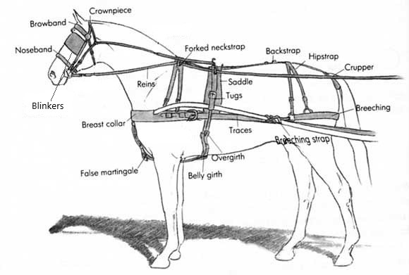
- Harness: noun, the assemblage of leather or synthetic straps and metal pieces by which an equine is attached to a vehicle, plow, load
- Blinkers: pair of leather or rubber eye cups attached to the driving bridle to limit rear vision and keep the equine’s vision focused forward
- Breast Collar: the part of the harness that fits around the chest of the equine and against which the animal exerts pressure in pulling a load
- Breeching: a harness strap that goes around the equine’s hindquarters to help hold back or stop the vehicle on a downgrade
- Breeching straps: straps that attach the breeching to the shafts of the driving vehicle
- Crupper: a padded leather strap that goes around the base of an equine’s tail and is used to keep the harness in place on the equine’s back and keep it from slipping forward
- Saddle: a padded part of a harness worn over the equine’s back to hold the shafts
- Traces: the two leather or synthetic straps that connect the harness to the vehicle
- Tugs: the part of the harness used in a single hitch through which the shafts pass

Glossary of Driving Terms

ABW (Able-Bodied Whip): a whip with the skills to drive a horse and vehicle unassisted. These skills include a minimum of 50 hours of driving experience in various terrain and conditions and complete knowledge of harness and vehicle terminology, competencies in managing emergencies. The ABW will hold a second set of reins while the driving student enters and exits the vehicle and assist with the second set of reins as needed during the driving lesson.
Advanced Independent Driver (AID): a whip with the ability to safely drive a vehicle without an able-bodied whip. The AID should demonstrate ability to direct the header, respond appropriately to the Driving Instructor and be independent in safely managing the equine and turnout using the whip and reins attached to the bit.
Bit: the part of the bridle that goes into the equine’s mouth, used to control the equine
Blinkers: a pair of leather or rubber eye cups attached to the driving bridle to limit rear vision and keep the equine’s vision focused forward
Breast collar: the part of the harness that fits around the chest of the equine and against which the animal exerts pressure in pulling a load
Breeching: a harness strap that goes around the equine’s hindquarters to help hold back or stop the vehicle on a downgrade
Breeching Straps: straps that attach the breeching to the shafts of the driving vehicle Bridle – a head harness for guiding an equine; it consists of a headstall, bit and reins
Cart: a two-wheeled driving vehicle
Carriage: a four-wheeled driving vehicle Collar – pad going around the equine’s neck, accommodating the hames to which two traces are attached, an alternative to a breast collar
Crupper: a padded leather strap that goes around the base of an equine’s tail and is used to keep the harness in place on the equine’s back and keep it from sliding forward
Halter: a bit less headstall for tying or leading an animal
Harness: (noun) the assemblage of leather or synthetic straps and metal pieces by which an equine is attached to a vehicle, plow or load; verb: to attach an equine with a harness to something such as a carriage
Header: a trained equine handler who stands at the head of the equine with an attached lead line whenever the equine is standing still. A header is required while the equine is being put to or taken from the vehicle, while client is entering or exiting the vehicle and available whenever assistance with the equine is needed.

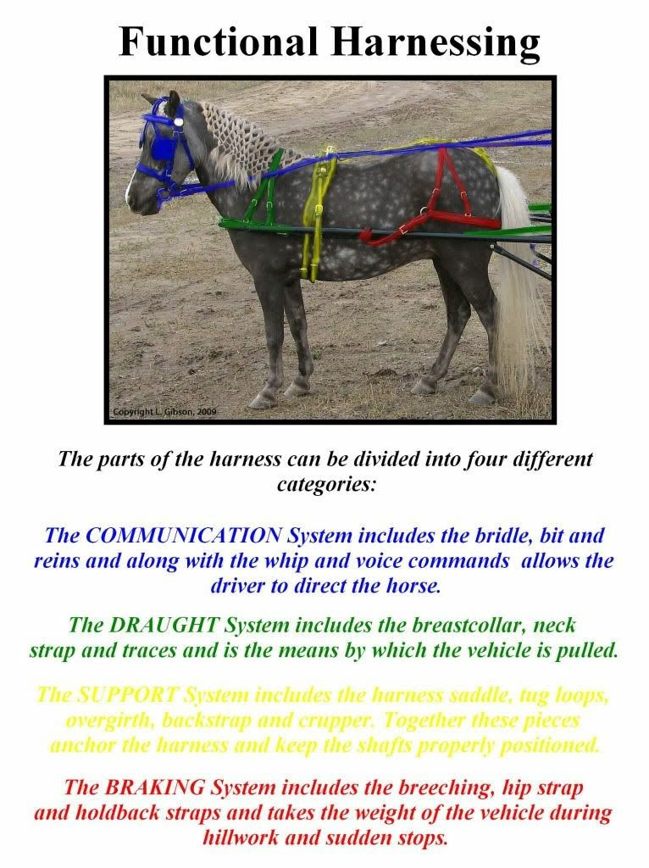

Wraps
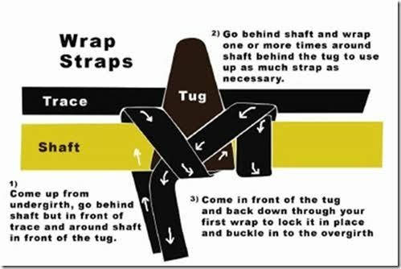

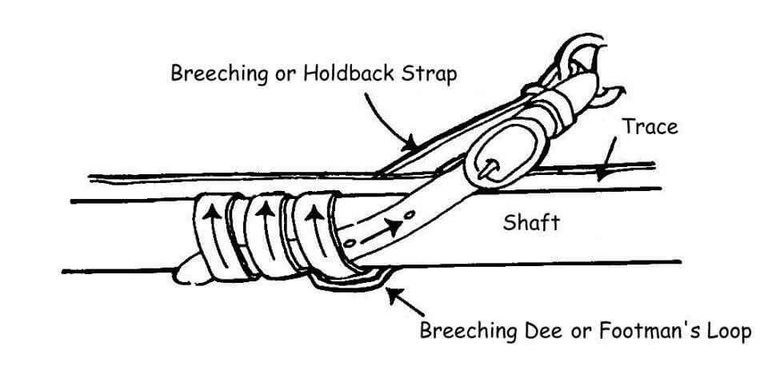

This is an example of how the hold back straps are buckled during a lesson.
This ensures effective use of the harness with minimal wear and damage to the equipment.

